Assignment Day-12

Name: Kanak Agrawal

Email: [kanakagrawal2001@gmail.com](mailto:kanakagrawal2001@gmail.com)

Date: 05-02-2024

**Question:** This is the screenshot of today’s hand written notes

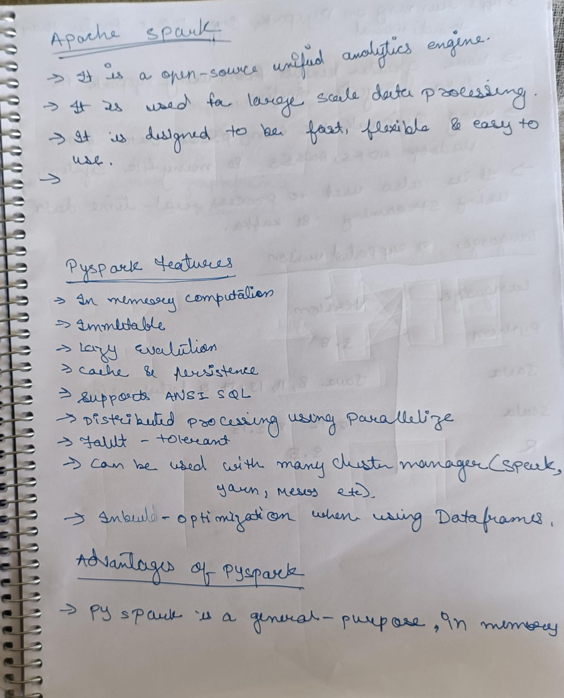

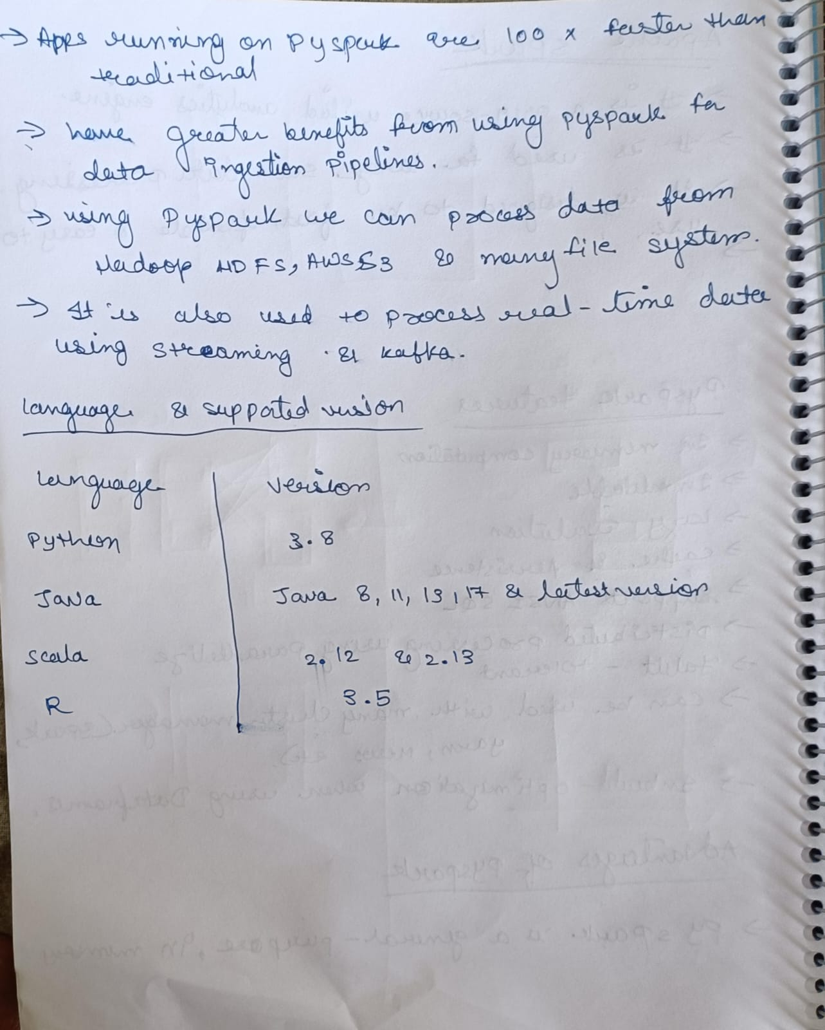

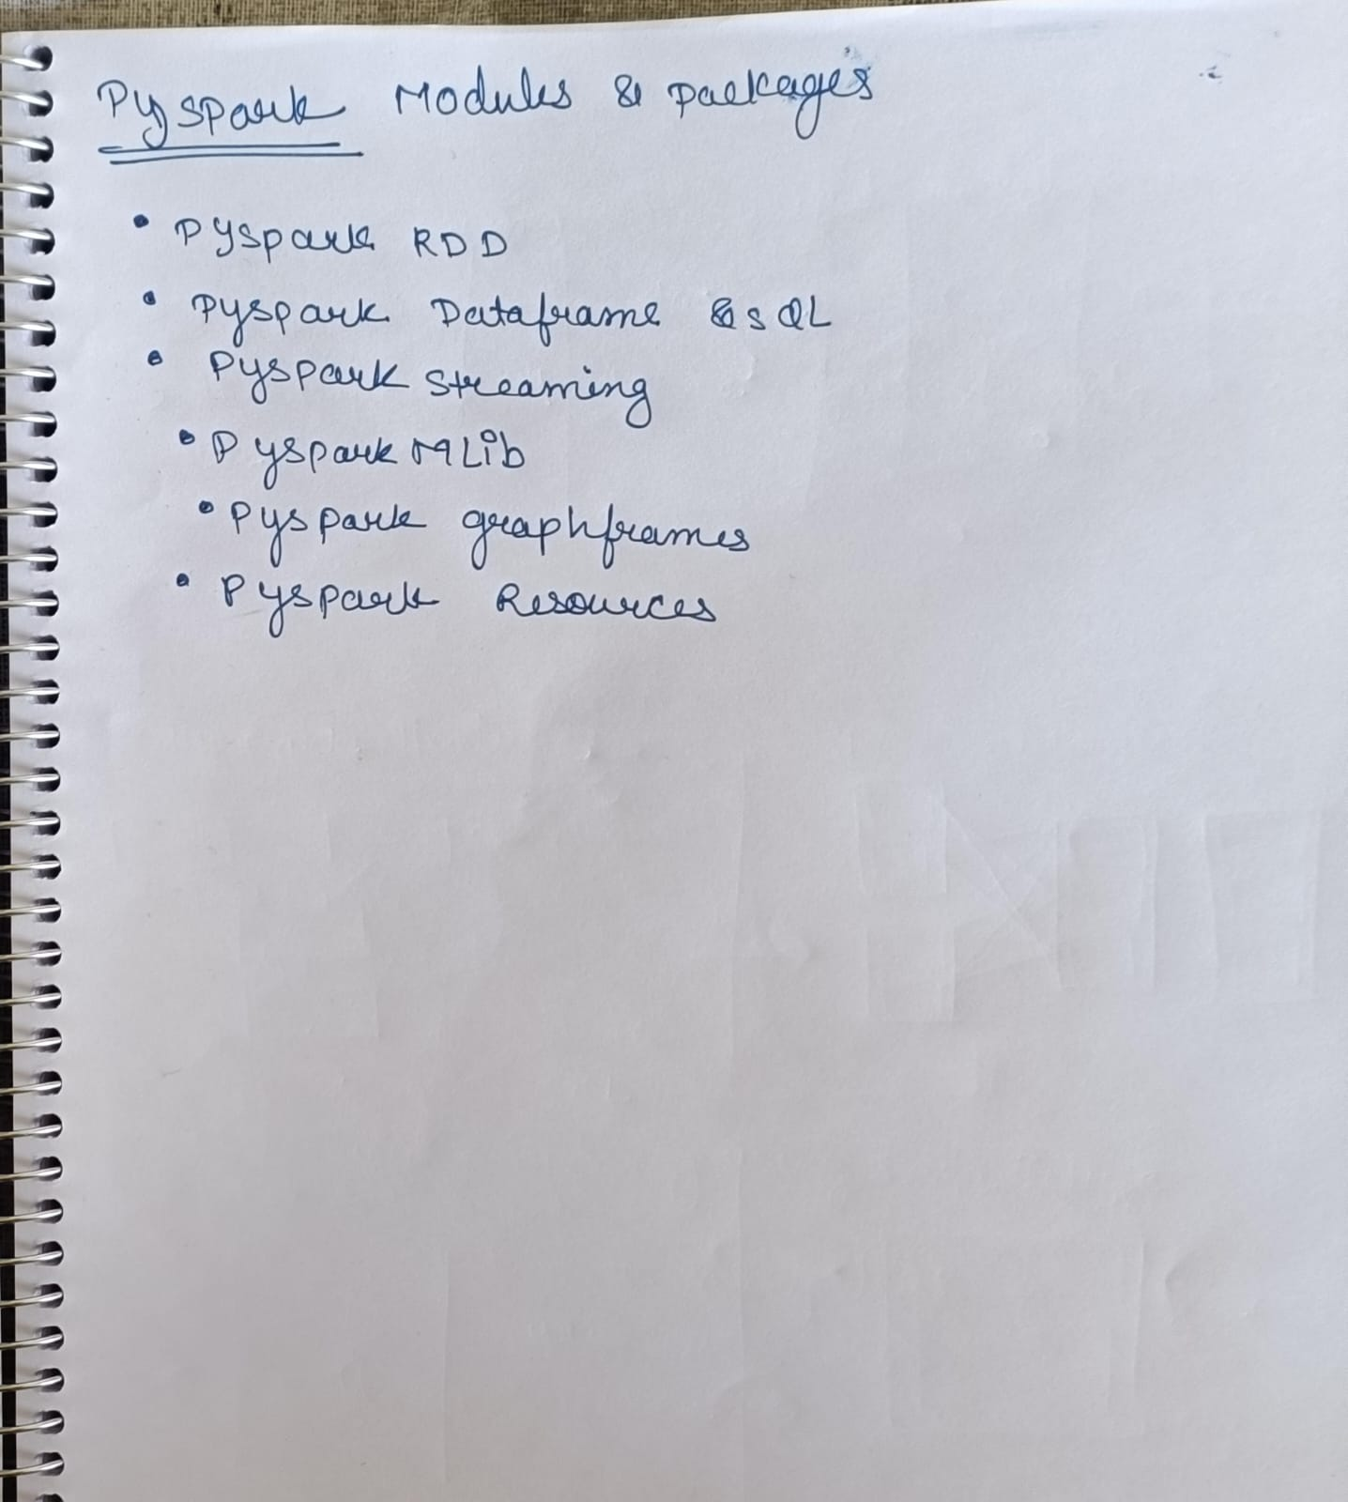

**And here is the screenshot of Jupyter Notebook**

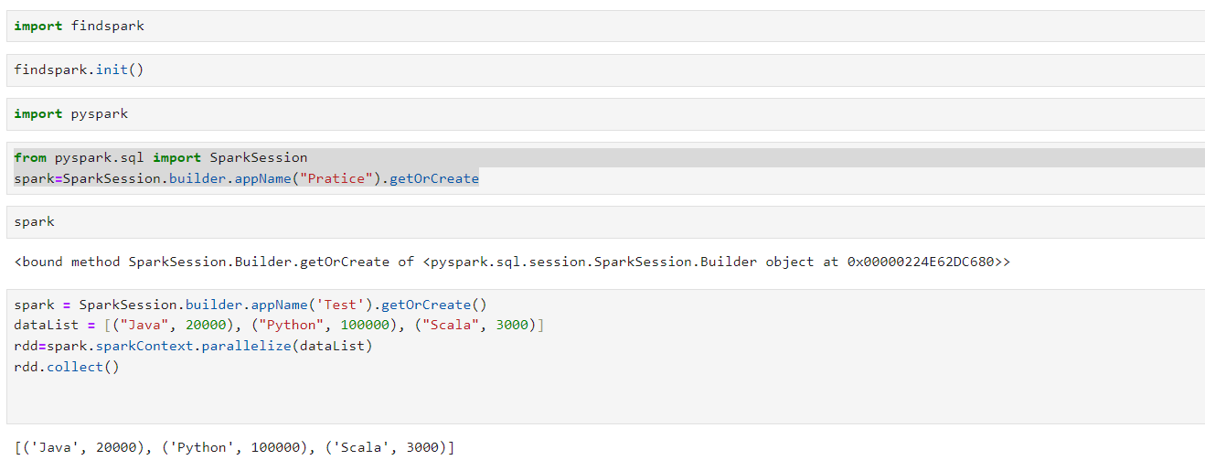

**And here is the screenshot of Databricks**

Using upload csv file option

**Code:**

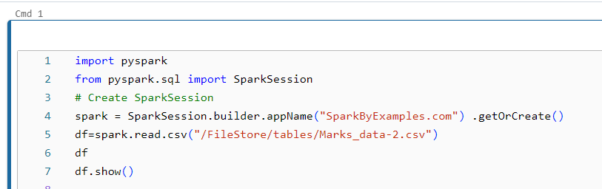

**Output:** 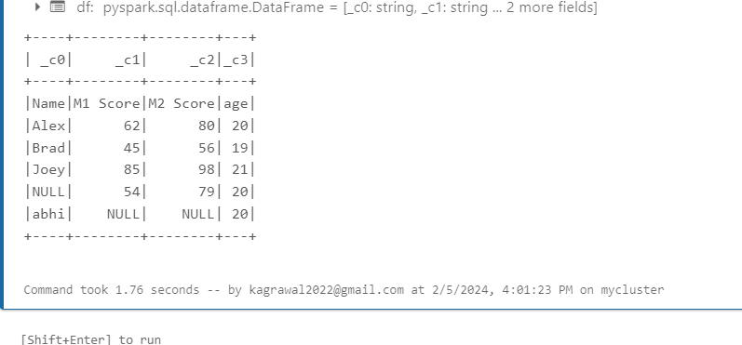

**Using Datalist option**

